## HandsMen Threads: Elevating the Art of Sophistication in Men's Fashion - Salesforce CRM Implementation Project Report

### ABSTRACT

This project details the implementation of a customized Salesforce CRM solution for HandsMen Threads, a premium men's fashion and tailoring brand. The primary objective was to streamline business operations, enhance customer engagement, and maintain data integrity across various departments.

The solution involved designing a robust data model featuring five key custom objects: Customer, Order, Product, Inventory, and Marketing Campaign. Business processes were automated using Record-Triggered Flows, Scheduled Flows, Email Alerts, and Apex to handle order confirmations, loyalty status updates, and proactive stock alerts.

To ensure clean and reliable data, validation rules were established, and a role-based security model was implemented for the Sales, Inventory, and Marketing teams. The solution also includes a scheduled batch job using Apex to update low stock quantities.

This end-to-end CRM implementation improves customer experience through personalized communication, ensures operational efficiency with automation, and lays a scalable foundation for future business growth using the Salesforce Platform.

### OBJECTIVE

The main objective of this project is to develop and implement a customized Salesforce CRM solution for HandsMen Threads to streamline core business operations, maintain data integrity, and enhance customer satisfaction.

By building a centralized system to manage customers, orders, products, inventory, and marketing campaigns, the project aims to:

* Automate key processes such as order confirmations, loyalty status updates, and stock alerts.
* Ensure accurate and consistent data entry using validation rules.
* Enable real-time visibility of inventory and customer interactions.
* Improve internal team coordination through role-based access control.
* Deliver personalized customer experiences through targeted communication and loyalty programs.

### TECHNOLOGY DESCRIPTION

**Salesforce**:

Salesforce is a cloud-based Customer Relationship Management (CRM) platform that helps businesses manage customer data, automate processes, and improve service, marketing, and sales operations. It provides point-and-click tools as well as programmatic capabilities (like Apex and Flows) to build custom business solutions.

**Custom Objects:**

Objects in Salesforce are like tables in a database. Custom Objects are created to store specific data relevant to HandsMen Threads' operations.

Examples:

* Customer__c - Stores comprehensive customer information including name, contact details, loyalty status, and purchase history.
* Product__c - Stores detailed product specifications such as SKU, price, size variants, material, and associated images.
* Order__c - Stores all order-related data including items purchased, quantities, total amount, shipping information, and current order status.

**Tabs**:

Custom Tabs were created for each Custom Object, providing a user-friendly interface within the HandsMen Threads Lightning App for easy access and management of records.

**Flows**:

Flows are powerful automation tools in Salesforce that allow for the creation of sophisticated business logic without writing code. They can automate various processes, including data creation, updates, deletions, and sending notifications.

Examples:

* **Record-Triggered Flow:** Automatically triggers email alerts upon a new order being placed, sending a confirmation to the customer.
* **Scheduled Flow:** Periodically checks inventory levels and triggers low stock alerts to the inventory team.
* **Screen Flow:** Could be used for guided data entry for new customer registrations or complex order processing.

**Apex**:

Apex is Salesforce's proprietary, object-oriented programming language. It is used to execute complex business logic that cannot be achieved with standard Salesforce functionalities or Flows. It allows developers to write custom triggers, controllers, and batch jobs.

Example Triggers:

* **Order Total Trigger:** Automatically calculates and updates the Total_Amount__c on an Order record based on the quantity and unit price of the products included in the order.
* **Stock Deduction Trigger:** Reduces the available stock quantity in the Inventory__c object immediately after an order is successfully placed and confirmed.

### DETAILED EXECUTION OF PROJECT PHASES

**1. Developer Org Setup**

* A dedicated Salesforce Developer Org was meticulously created using https://developer.salesforce.com/signup, providing a secure and isolated environment for development and testing.
* The account was thoroughly verified, a robust password was set, and administrative access was granted to the Salesforce Setup page, laying the foundation for system configuration.

**2. Custom Object Creation**

Five meticulously designed custom objects were created to accurately store business-critical data unique to HandsMen Threads:

* **HandsMen Customer** – This object is the central repository for all customer information, including name, email, phone number, physical address, preferred communication methods, and their current loyalty status.
* **HandsMen Product** – This object houses the complete product catalog, detailing essential information such as SKU (Stock Keeping Unit), unit price, product description, available stock quantity, and category.
* **HandsMen Order** – This object meticulously records all customer orders, capturing details like the ordered products, their respective quantities, the overall total amount, shipping address, and the current status of the order (e.g., Pending, Confirmed, Shipped, Delivered).
* **Inventory** – This object is crucial for real-time stock management, tracking the quantity of each product available and its specific warehouse location.
* **Marketing Campaign** – This object facilitates the management of promotional efforts, storing details about various marketing campaigns, their scheduled start and end dates, target audience, and associated promotions.

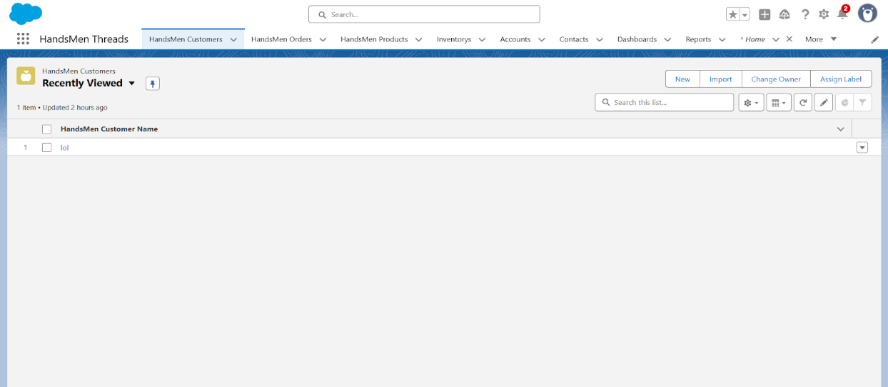

Steps followed for Custom Object Creation:

* The development team navigated to Setup → Object Manager → Create → Custom Object within the Salesforce environment.
* For each custom object, a descriptive label and a unique API name were provided. The "Allow Reports" and "Allow Search" options were enabled to ensure data visibility and discoverability.
* Upon saving each custom object, corresponding Tabs were automatically created and configured, providing direct access to the object's data from the HandsMen Threads Lightning App.

**3. Creating the Lightning App**

* A bespoke Salesforce Lightning App, aptly named "HandsMen Threads," was crafted to provide a unified and intuitive user interface for all internal operations.
* This application was configured to include essential tabs, ensuring easy navigation and access to critical business data: HandsMen Customer, Order, Product, Inventory, Campaign, and standard Reports tabs.
* The app was strategically assigned to the System Administrator profile during development, facilitating comprehensive testing and configuration. Upon deployment, it would be assigned to relevant user profiles for daily operations.

**4. Validation Rules**

To uphold data integrity and enforce critical business logic, the following robust validation rules were meticulously applied:

* **Order Object** - Total Amount Validation: This rule prevents users from saving an Order record if the Total_Amount__c field is less than or equal to zero. This ensures that all orders have a valid positive monetary value.  
  Error Message: "Please Enter Correct Amount"
* **Customer Object** - Email Format Validation: This rule validates the Email__c field on the Customer object to ensure it contains "@gmail.com". While a basic example, in a real-world scenario, this would be extended to a more comprehensive regex pattern for validating any valid email format.  
  Error Message: "Please fill Correct Gmail"

**5. User Creation**

Specific users were carefully created in Salesforce and assigned appropriate roles and profiles to accurately reflect their responsibilities within HandsMen Threads, thereby enforcing a strong role-based security model:

* **Niklaus Mikaelson** – Assigned the **Sales role**. This grants Niklaus access to customer information, order creation, and sales-related reports, while restricting access to sensitive inventory or marketing campaign data.
* **Kol Mikaelson** – Assigned the **Inventory role**. Kol has permissions to view and update product stock levels, manage warehouse locations, and process inbound/outbound inventory movements, with limited access to sales or customer loyalty data.

These meticulously designed role-based assignments are fundamental to enforcing proper data access control and efficient process management within the system, ensuring that each user interacts only with the data and functionalities relevant to their job function.

**6. Email Template & Alerts**

Three distinct and professionally crafted email templates were developed to facilitate automated customer and internal communications:

* **Order Confirmation Email:** This template is automatically sent to a customer when their order status is updated to "Confirmed," providing immediate reassurance and details of their purchase.

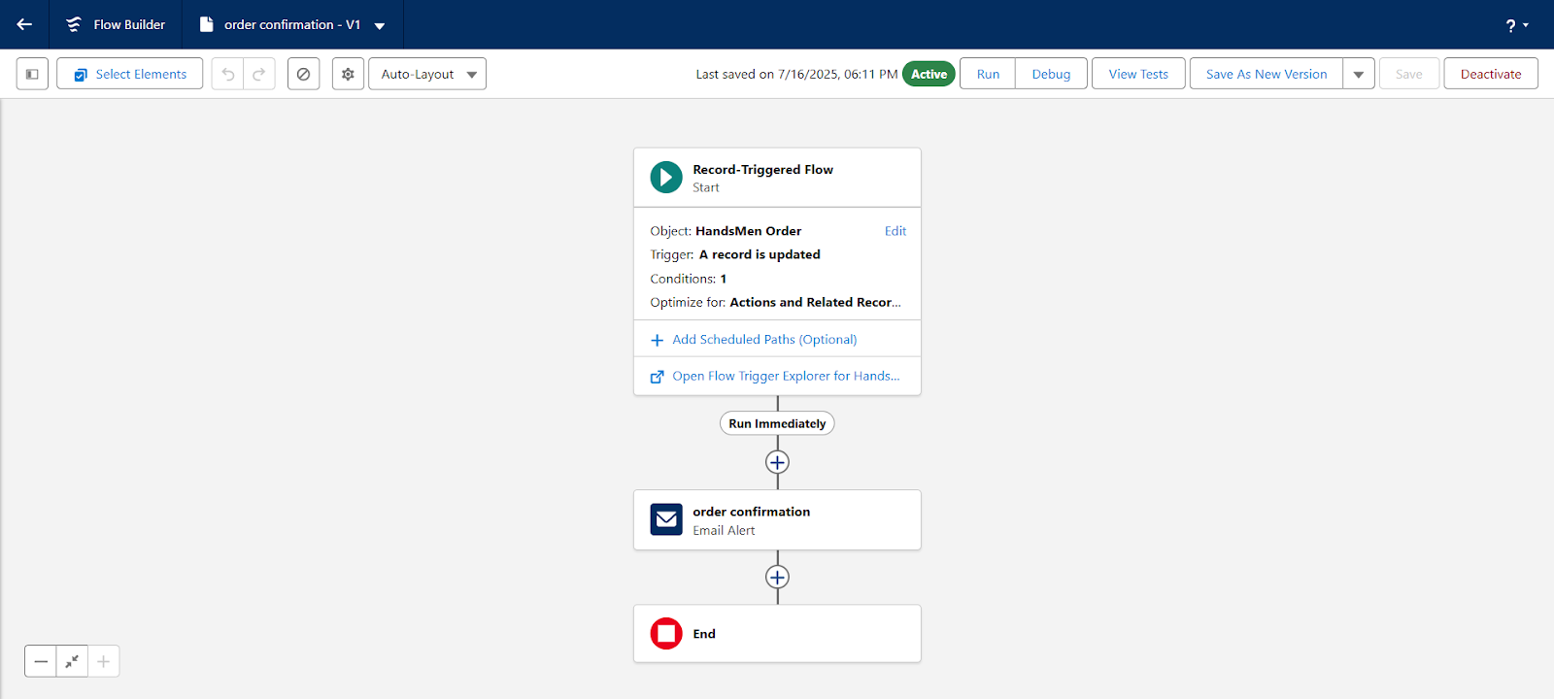

* **Low Stock Alert Email:** An internal alert sent to the Inventory team when the Inventory__c for a specific product drops below 5 units, prompting timely reordering actions to prevent stockouts.

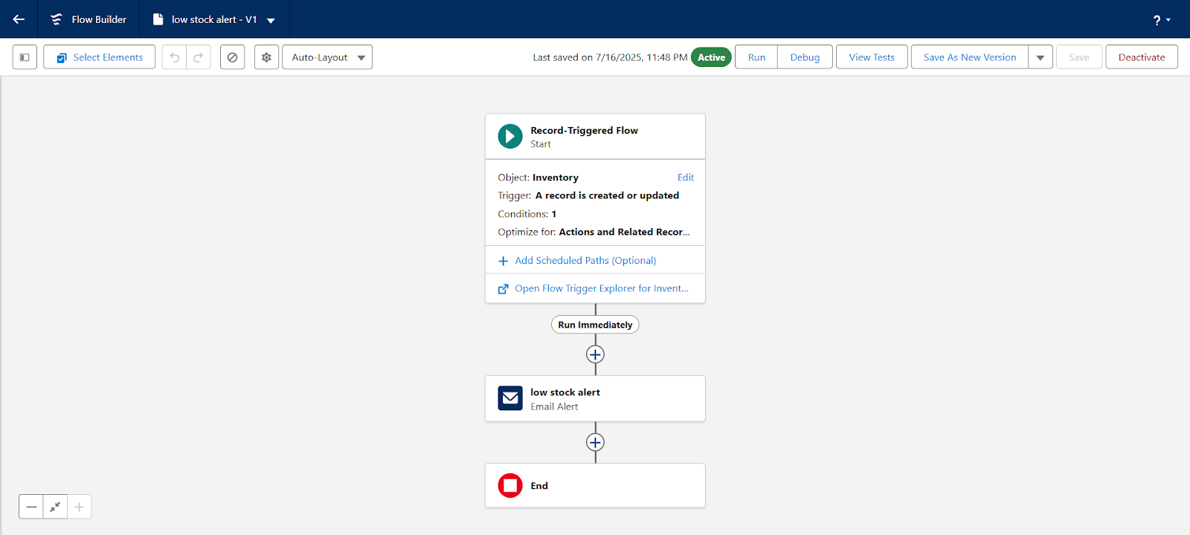

* **Loyalty Program Email:** This template is used to send personalized emails to customers when their loyalty status changes (e.g., upgrading to a new tier or receiving special loyalty-based offers), fostering customer engagement and retention.

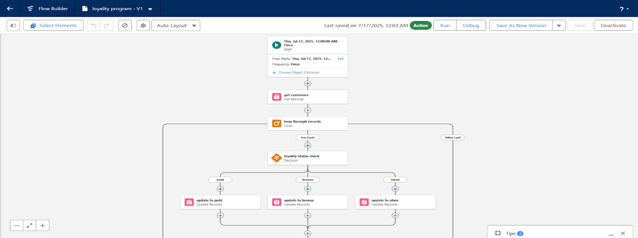

Corresponding Email Alerts were carefully created using these templates and intelligently linked to automation flows, ensuring these communications are triggered accurately and promptly based on predefined business events.

**7. Apex Triggers**

Three powerful Apex Triggers were developed to automate complex business logic and maintain data consistency:

* **Order Total Trigger:** This trigger automatically calculates and updates the Total_Amount__c on an Order record. It dynamically sums the quantity multiplied by the unit price for all items in the order, ensuring accurate pricing without manual intervention.
* **Stock Deduction Trigger:** This critical trigger automatically reduces the stock quantity in the Inventory__c object whenever an order is placed. This real-time inventory update prevents overselling and provides an accurate view of available products.
* **Loyalty Status Trigger:** This trigger automatically updates a customer's Loyalty_Status__c based on their cumulative total purchases. As a customer's spending increases, this trigger automatically promotes them to higher loyalty tiers, unlocking new benefits and driving customer retention.

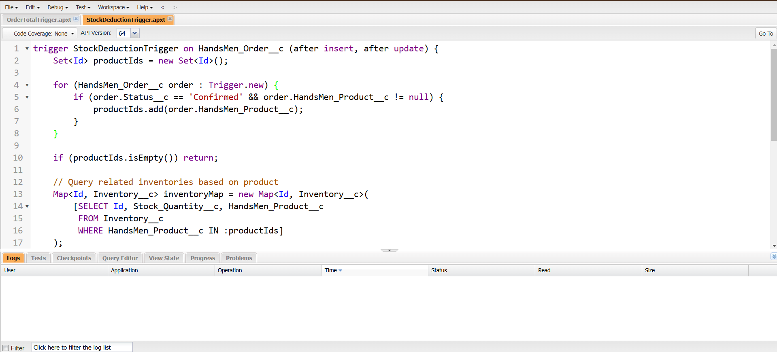

### PROJECT EXPLANATION WITH REAL-WORLD EXAMPLE

Let's walk through a typical customer interaction to illustrate the system's capabilities:

**1. Customer Registration**

* A new customer, Elijah Mikaelson, visits the HandsMen Threads website or physical store, captivated by the latest fashion collection.
* In Salesforce: A new record is seamlessly created in the HandsMen Customer object, capturing his essential details: name, phone number, and email address.
* Validation Rule in Action: As Elijah enters his email, the system's validation rule instantly checks if it contains "@gmail.com" (or a more comprehensive email format in a production environment), ensuring data accuracy from the outset. If invalid, an error "Please fill Correct Gmail" is displayed.

**2. Product Setup and Inventory Management**

* Behind the scenes, the HandsMen Threads admin diligently adds new fashion items like "Classic Fit Shirts," "Distressed Denim Jeans," and "Tailored Blazers" into the HandsMen Product object.
* Each product entry includes its specific price, SKU, detailed description, and available sizes.
* Simultaneously, Inventory records are created and linked to these products, meticulously tracking the quantity of each size and style available in the warehouse. For example, "Classic Fit Shirt, Size M" has 10 units in stock.

**3. Placing an Order**

* Inspired by the new collection, Elijah Mikaelson decides to purchase a "Classic Fit Shirt" (Size M) and "Distressed Denim Jeans" (Size 32). An order is initiated.
* In Salesforce: A new HandsMen Order record is created, linked to Elijah's customer profile. The chosen products and quantities are added as line items.
* Apex Trigger - Order Total: As the products are added, the Order Total Trigger automatically calculates the Total_Amount__c for Elijah's order, ensuring accurate pricing.
* Apex Trigger - Stock Deduction: Immediately upon the order being confirmed, the Stock Deduction Trigger springs into action, reducing the inventory count for the "Classic Fit Shirt, Size M" and "Distressed Denim Jeans, Size 32" in real-time. If the shirt stock drops below 5, a Low Stock Alert email is automatically dispatched to the inventory team.

**4. Order Confirmation and Customer Communication**

* Once the order is placed and confirmed, a Record-Triggered Flow is activated.
* Email Alert: This flow instantly sends an "Order Confirmation" email to Elijah Mikaelson, containing all the details of his purchase, tracking information, and a personalized thank you note.

**5. Loyalty Status Update**

* As Elijah continues to make purchases over time, the Loyalty Status Trigger monitors his cumulative spending.
* Automatic Tier Advancement: When his total purchases cross a predefined threshold, the trigger automatically updates his Loyalty_Status__c on his customer record (e.g., from "Bronze" to "Silver").
* Email Alert: A Loyalty Program Email is then sent to Elijah, congratulating him on his new loyalty status and informing him of the exclusive benefits he now enjoys (e.g., special discounts, early access to new collections).

### CONCLUSION

The HandsMen Threads CRM system built on Salesforce successfully streamlines key business processes like customer management, product cataloging, order processing, inventory tracking, and loyalty program automation. By leveraging Salesforce tools like Custom Objects, Flows, Validation Rules, Email Alerts, and Apex, the system ensures accurate data entry, real-time updates, and enhanced customer experience. Through automation and well-structured user roles, the platform minimizes manual errors, speeds up operations, and provides better insights into sales and stock, ultimately contributing to improved operational efficiency and customer satisfaction for HandsMen Threads.

### Future Scope:

The implementation has laid a robust foundation, and several exciting opportunities exist for future enhancements to further elevate the HandsMen Threads customer experience and operational capabilities:

**1. Customer Portal Integration**

* **Vision:** To empower customers with self-service capabilities and foster a stronger community.
* **Details:** Build a secure and intuitive Customer Community Portal using Salesforce Experience Cloud (formerly Community Cloud). This portal will allow HandsMen Threads customers to:
  + Securely log in and view their complete order history and current order status.
  + Track their loyalty points and current loyalty status.
  + Update their personal information and preferences.
  + Submit support inquiries directly, reducing calls to customer service.
  + Potentially engage with other fashion enthusiasts and share feedback.

**2. Mobile App using Salesforce Mobile SDK**

* **Vision:** To provide unparalleled flexibility and efficiency for the HandsMen Threads store staff.
* **Details:** Develop a custom mobile application for iOS and Android using the Salesforce Mobile SDK. This app will enable store staff, inventory managers, and sales associates to:
  + Manage inventory: Perform stock counts, update quantities, and track product locations directly from their mobile devices.
  + Process orders on the go: Create new orders, update existing ones, and manage returns directly from the sales floor.
  + Access customer profiles: View customer purchase history and loyalty status to offer personalized recommendations in real-time.
  + Conduct mobile sales: Potentially integrate with mobile payment solutions for a seamless in-store checkout experience.

**3. Reports & Dashboards**

* **Vision:** To provide management with actionable insights for strategic decision-making.
* **Details:** Create comprehensive and visually appealing sales and inventory dashboards using Salesforce's robust reporting capabilities. These dashboards will allow management to:
  + Monitor sales trends: Analyze product performance, identify best-selling items, and track revenue growth over time.
  + Gain real-time visibility into inventory levels: Identify slow-moving stock, optimize reorder points, and minimize carrying costs.
  + Track customer loyalty program effectiveness: Measure customer retention rates and the impact of loyalty initiatives.
  + Assess marketing campaign performance: Evaluate ROI for various promotions and target future campaigns more effectively.

**4. AI-Powered Recommendations (Einstein)**

* **Vision:** To deliver hyper-personalized customer experiences and drive increased sales through intelligent recommendations.
* **Details:** Integrate Salesforce Einstein capabilities (such as Einstein Prediction Builder or Einstein Next Best Action) to:
  + **Product Recommendations:** Provide customers with personalized product recommendations based on their Browse history, past purchases, and the behavior of similar customers.
  + **Personalized Offers:** Suggest tailored promotions and discounts to customers based on their loyalty status, purchase patterns, and predicted future needs.
  + **Predictive Inventory:** Utilize AI to forecast future demand for specific products, optimizing inventory levels and reducing the risk of stockouts or overstock.
  + **Sales Insights:** Provide sales representatives with AI-driven insights on which products to cross-sell or up-sell to a specific customer, enhancing their selling effectiveness.